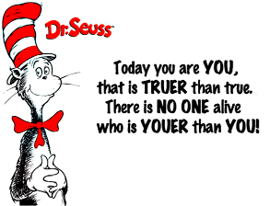
2022
Dear Jefferson Students and Parents,
Students will be celebrating “Read Across America” in the school library throughout the month of March with stories and trivia questions, joining school libraries across the country that do creativeevents at this time of year to celebrate the birthday of Dr. Seuss, aka Ted Geisel – combined with featuring colorful, fun stories that make turning those pages exciting!
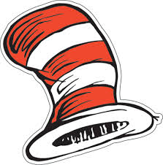
To start this fun event, students may voluntarily participate in dress-up days at school! The schedule of days is as follows:
Monday, February 28: Pajama Day (in honor of Seuss’ Sleep Book) - Students may dress in pajamas! Pajamas must be appropriate to wear in class. No slippers please. Wear safe, closed-toe shoes.
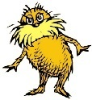
Tuesday, March 1:Twin or Triplet Day(in honor of Seuss’ Thing One & Thing Two) OR Wear GREEN Day! (in honor of Green Eggs & Ham) – Students may choose to dress similarly to one or two of their classmates and/or wear GREEN today!
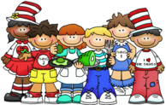
Wednesday, March 2:Sports & Cartoons Day (in honor of Seuss’ Wacky Wednesday): Students may choose to wear clothing and accessories of their favorite sports team, and/or clothing of their favorite cartoon character.
Thursday, March 3:Crazy Hat or Hair Day / Backward (or inside out) Shirt Day (in honor of Seuss’ The 500 Hats of Bartholomew Cubbins): Students may choose to do silly things with their hair and/or wear a funny hat. Hats must be able to be removed during the day if needed. Tops may be worn backward or inside out, as well.
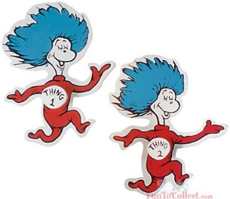
Friday, March 4: SCHOOL SPIRIT Day and/or Silly mustache / beard / furry eyebrows day: Students may wear silly mustaches / facial hair to school, in honor of our furry friend THE LORAX! (We realize this may be difficult with masks – students may draw facial hair over disposable masks, if they wish.) Students may also wear their Jefferson t-shirts, or a red/white/blue theme, for school spirit!
**** These dress-up days are completely optional for the students. ****
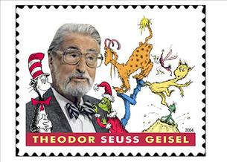
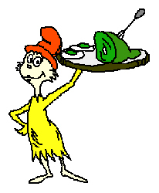
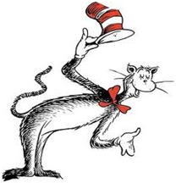
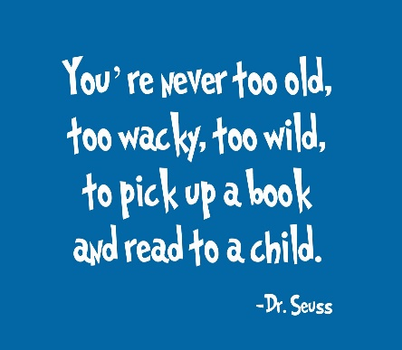

~ Melissa Ednalino (“Mrs. E”)
Jefferson School Library

